|  |  |
| --- | --- |
| **Soal Praktikum**  *Practicum Case* | LogoBINUS-University |
| T0026  Struktur Data |
| **Kelas**  *Class* | **Jurusan**  *Department*  **Teknik Informatika**  *Computer Science* |
| **Periode Berlaku** Semester Ganjil 2012/2013  ***Valid on*** *Odd Semester Year 2012/2013* | **Revisi 00**  *Revision* |

## Tujuan Instruksional Khusus

*Special Instructional Course*

* Mahasiswa memahami dan mengimplementasi Double Linked List

## Pokok Bahasan

*Subject Discussion*

* Double Linked List

## Materi

*Material*

* Double Linked List
* Push di depan head
* Pop tengah
* Pop tail

## Soal

*Case*

Your friend really loves music. It is near to his birthday so you, as the best friend, want to give him a present. As a programmer, you want give him a music application named **V-Music Player**. Here are the descriptions of the program:

* The program always shows the song list (**No** and **Song Title**). The list of the songs displayed:

1. Summer Song
2. Goodbye Days
3. Umareyuku Monotachi e
4. Candle Light
5. Especially For You
6. Never Say Never
7. When You Love Someone

* The program has 4 menus:
  1. Move cursor up
  2. Move cursor down
  3. Remove this song
  4. Exit
* At the right side of the **Song Title,** there is a cursor that can moved up and down
* If user chooses **Move cursor up**, then:
* Move up the cursor.
* If the cursor has been at the top, the cursor cannot move up anymore and please show the message “**Already at the top of the list**”
* If user chooses **Move cursor down**, then:
* Move down the cursor.
* If the cursor has been at the bottom, the cursor cannot move down anymore and please show the message “**Already at the end of the list**”
* If user chooses **Removed this song,** then:
* The current selection of the song will be removed from the song list.
* If user chooses **Exit,** the program ends.

**Please run the EXE file to see the sample program.**

**Print Screen of Main Menu**

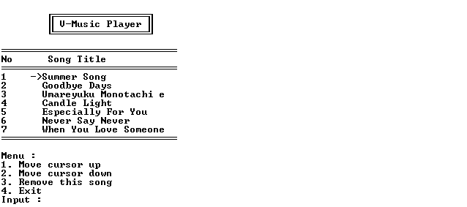

**Print Screen of Move Cursor Down Menu (Menu ‘2’)**

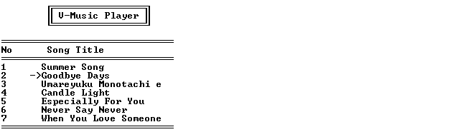

**Print Screen of Move Cursor Down Menu (Menu ‘1’)**



**Print Screen of Remove This Song Menu (Menu ‘3’)**

